Name ____________________________________

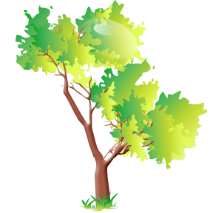

Mrs. Hodge asked Annie’s class to write an essay about TREES. Write an essay about a special tree in *your* life. Maybe you have a funny story about a tree. Perhaps you’ve found a bird’s nest or have climbed a tree or fell out of a tree. Perhaps you have a favorite tree where you like to sit and think. Or maybe you’ve helped plant a tree. If you can’t think of a special tree, then write about how you feel about trees. Do you like them? Do you think trees are “ultra-fab-licious” like Jazz? Or are you like mean ol’ Leroy and “hate trees guts”?

**TREES**

________________________________________________________________________________________________________________________________________________________________________________________________________________________________________________________________________________________________________________________________________________________________________________________________________________________________________________________________________________________________________________________________________________________________________________________________________________________________________________________________________________________________________________________________________________________________________________________________________________________________________________________________________________________________________________________________________________________________________________________________________________________________________________________________________________________________________________________________________________________________________________________________________________________________________________________________________________________________________________________________________________________________________